Date | 15 Feb 2026
Team ID | LTVIP2026TMIDS43270
Project Name | Visualization Tool for Electric Vehicle Charge and Range Analysis with Tableau
Maximum Marks

project report

ELECTRIC VEHICLE CHARGE & RANGE ANALYSIS DASHBOARD
Using Tableau for EV Data Visualization

1. INTRODUCTION
1.1 Background
The rapid growth of Electric Vehicles (EVs) has transformed the global transportation industry. Governments are promoting EV adoption to reduce carbon emissions and dependency on fossil fuels. However, the success of EV implementation depends heavily on efficient charging infrastructure, battery performance monitoring, cost analysis, and vehicle efficiency comparison.
With increasing EV brands and charging stations, stakeholders face challenges in analyzing scattered data related to pricing, efficiency, range, and infrastructure distribution. Data visualization tools like Tableau provide powerful solutions to convert raw EV datasets into actionable insights.

1.2 Project Overview
The Electric Vehicle Charge & Range Analysis Dashboard is a Tableau-based data visualization project that integrates EV car specifications and charging station datasets to generate meaningful insights.
This project focuses on:
- EV charging station distribution across India
- Brand-wise EV model comparison
- Price and top speed comparison
- Efficiency ranking (km/kWh)
- Powertrain and body style distribution
- Interactive storytelling using Tableau Story feature
The dashboard transforms raw CSV datasets into interactive visual insights to assist decision-making for EV buyers, fleet operators, and policymakers.

1.3 Objectives
The main objectives of this project are:
- To design an interactive EV analytics dashboard
- To analyze EV price, efficiency, and performance trends
- To visualize charging infrastructure distribution
- To compare EV brands and models
- To provide story-based visualization for presentations
- To publish and embed dashboards for web accessibility

2. IDEATION PHASE
2.1 Problem Statement
With the rapid growth of the EV market, stakeholders lack a centralized visualization platform to compare EV brands, analyze efficiency, monitor charging station distribution, and evaluate performance metrics. Data is often stored in CSV files or reports without interactive insights. This limits informed decision-making and slows infrastructure planning.

2.2 Target Users
The primary users of this dashboard include:
- EV buyers comparing brands and prices
- Fleet managers monitoring EV performance
- Government authorities analyzing charging infrastructure
- Sustainability officers tracking efficiency
- Market analysts studying EV trends

2.3 Empathy Map
Think & Feel:
- “Which EV offers the best range for its price?”
- “Are there enough charging stations in my region?”
- “Which brand is most efficient?”
See:
- Multiple EV brands with varied price ranges
- Limited charging stations in some regions
- Technical specifications difficult to interpret
Hear:
- Government EV policies
- Sustainability goals
- News about EV market growth
Say & Do:
- Compare EV brands online
- Search charging station availability
- Analyze reviews and performance
Pains:
- High EV prices
- Lack of charging infrastructure
- Confusing technical data
Gains:
- Clear comparison insights
- Efficient brand identification
- Better purchasing decisions

2.4 Brainstorming
During the brainstorming session, the team generated a wide range of ideas focused on improving the effectiveness of the Electric Vehicle Charge & Range Analysis Dashboard. All members actively participated and contributed ideas without judgment to encourage creativity and innovation. The goal was to list as many relevant features and visualizations as possible before selecting the most impactful ones.

Initially, ideas were listed individually by each team member. These included developing a charging station map of India, creating a price versus range comparison chart, building a top 10 efficient EV brands visualization, and designing KPI summary cards to display average price and efficiency. Additional ideas such as brand-wise model count, powertrain type breakdown, body style comparison, and top speed analysis were also proposed. The team further suggested incorporating interactive filters for brand, region, and powertrain type to enhance user experience. Story-based dashboard navigation and web integration using Tableau Public were also considered to improve presentation and accessibility.
After listing all ideas, the team grouped them into meaningful categories. The first category, Infrastructure Analysis, included charging station mapping and regional distribution analysis. The second category, Performance Analysis, covered efficiency ranking, top speed comparison, and range evaluation. The third category, Market & Brand Analysis, consisted of price comparison, model count by brand, and body style distribution. The fourth category, Dashboard Features & User Experience, included KPI cards, interactive filters, story view design, and web publishing.
This structured grouping helped the team clearly understand how each idea contributes to the overall objective of building a comprehensive EV analytics dashboard. It also made the prioritization process more systematic and efficient.
3. REQUIREMENT ANALYSIS
3.1 Functional Requirements
- Interactive filters (Brand, Region, Powertrain)
- Charging station map visualization
- Efficiency ranking charts
- Price comparison charts
- Story-based dashboard navigation
- KPI summary cards

3.2 Non-Functional Requirements
- Dashboard loading time under 5 seconds
- Responsive layout for presentations
- Accurate KPI calculations
- Secure publishing via Tableau Public
- Scalability for additional datasets

3.3 Data Requirements
The project uses two primary datasets:
- EV Car Specifications Dataset
  - Brand
  - Model
  - Price
  - Top Speed
  - Efficiency (km/kWh)
  - Powertrain Type
  - Body Style
- Charging Station Dataset
  - Region
  - Charging Station Type
  - Location Coordinates
Total Records: 1000+ entries
4. SYSTEM DESIGN
4.1 Data Flow Diagram

CSV Dataset
↓
Data Cleaning & Preprocessing
↓
Import into Tableau
↓
Visualizations (Charts & Maps)
↓
Dashboard Design
↓
Story Creation
↓
Publish to Tableau Public

4.2 Solution Architecture
User Interface Layer:
- Tableau Dashboard (Web-based)
- Interactive filters and KPI cards
Application Layer:
- Tableau Calculated Fields
- Data filtering and aggregation logic
Data Layer:
- CSV datasets
- Optional cloud storage
Deployment Layer:
- Tableau Public
- Embedded via HTML iframe

5. PROJECT PLANNING & SCHEDULING
5.1 Project Planning Table

Phase | Task | Time (Days)
Phase 1 | Dataset Collection | 1
Phase 2 | Data Cleaning & Preparation | 2
Phase 3 | Visualization Creation | 2
Phase 4 | Dashboard & Story Design | 2
Phase 5 | Performance Testing | 1
Phase 6 | Web Integration & Publishing | 1
Phase 7 | Documentation & Report Writing | 3

6. FUNCTIONAL AND PERFORMANCE TESTING
6.1 Performance Testing
· Amount of Data Loaded: 1000+ EV & charging records
· Data Filters Used: Brand, Region, Powertrain Type, Body Style
· Calculation Fields: Efficiency Ranking, Model Count, Avg Price, Station Count
· Number of Visualizations: 9+
· Test Result: Smooth interaction with filter response under 3–5 seconds

7. RESULTS
7.1 Output Screenshots
- EV Charging Stations Map:

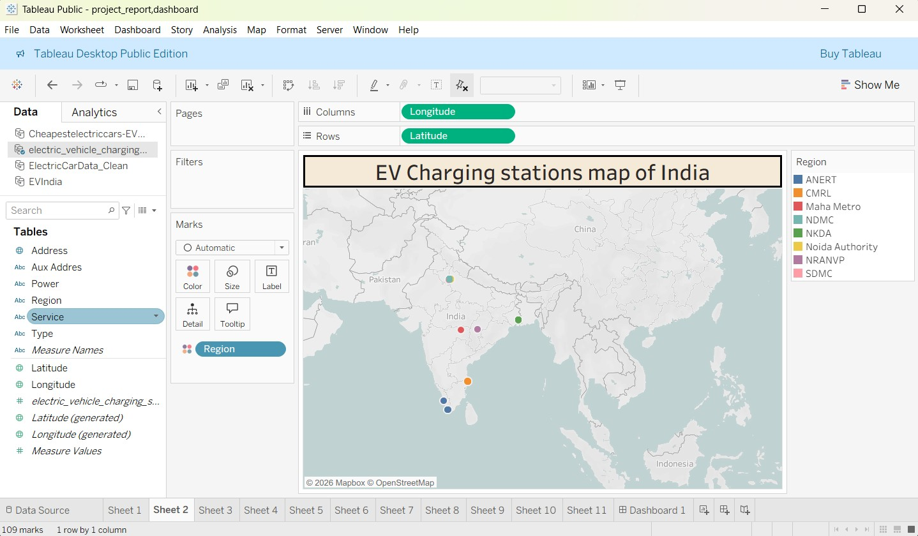

- Top Speed Comparison Chart:

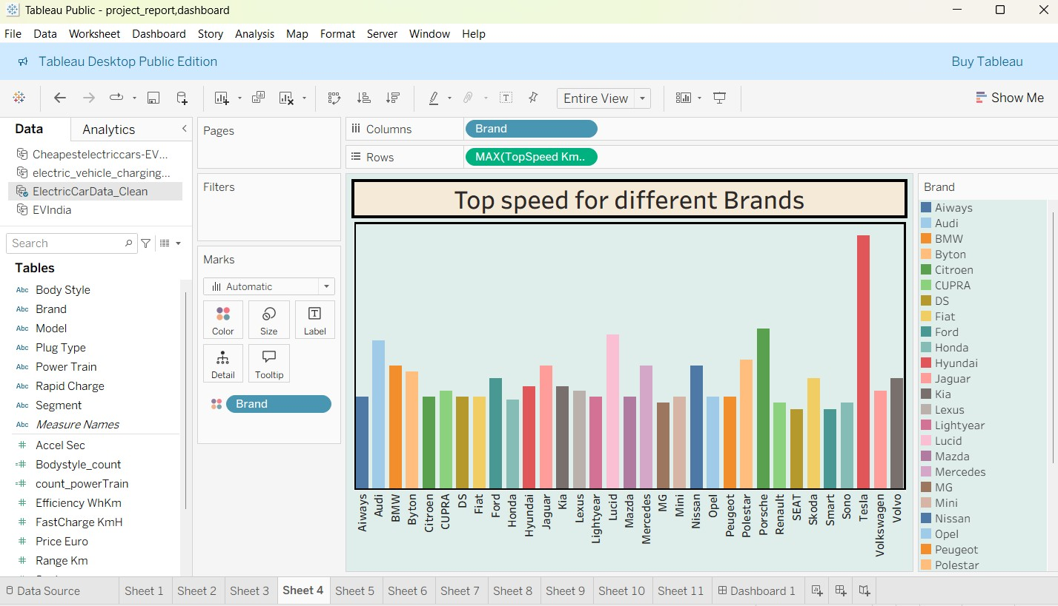

- Price Comparison Dashboard:

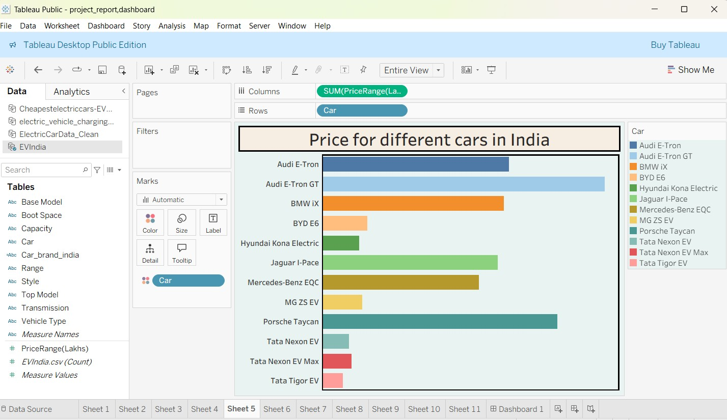
- Efficiency Ranking Visualization:

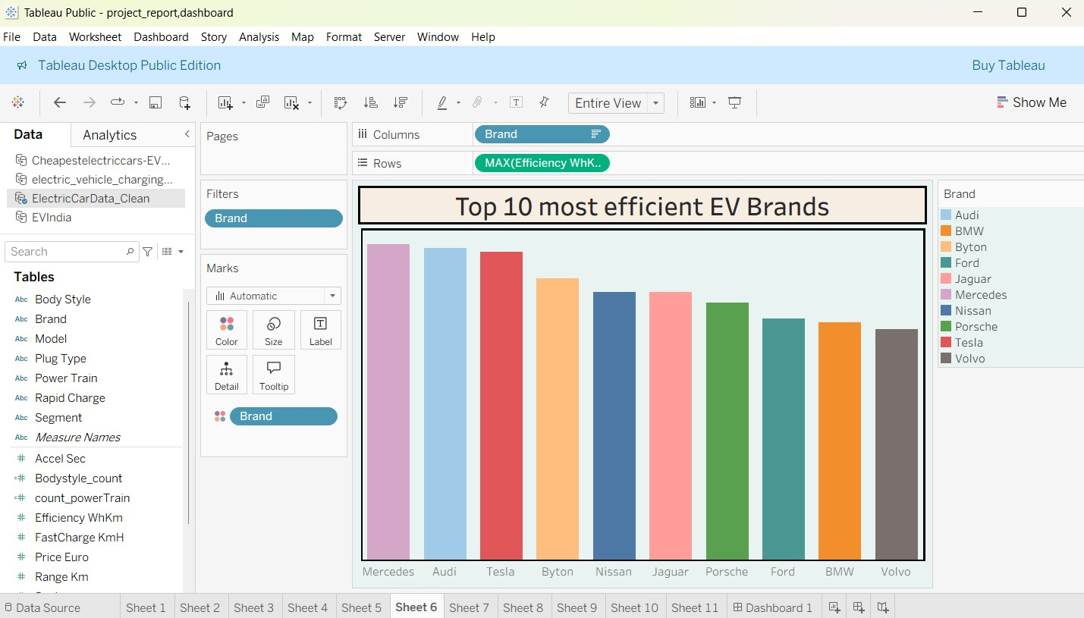
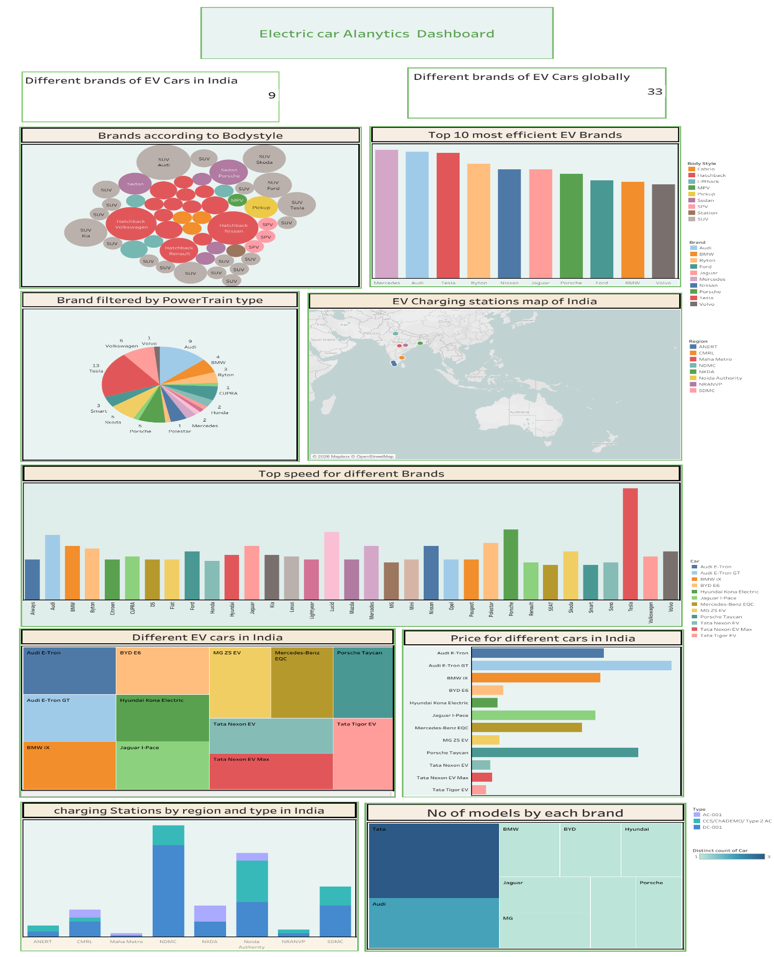
- Dashboard:

- Story View for Strategic Insights

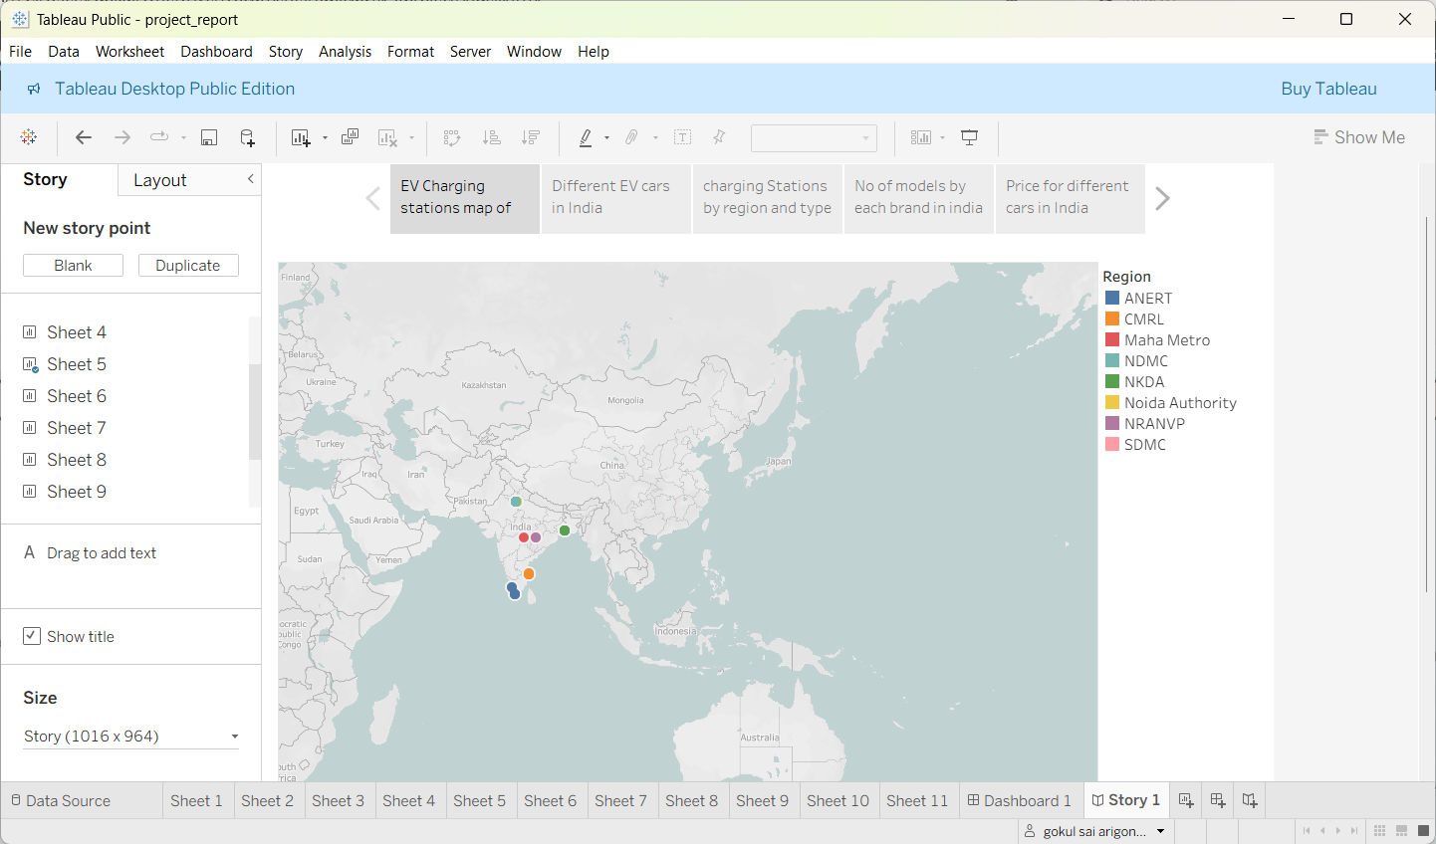

8. ADVANTAGES & DISADVANTAGES
Advantages
· Easy to interpret EV performance insights
· Centralized infrastructure visibility
· Interactive and story-driven presentation
· Supports data-driven planning
Disadvantages
· Requires Tableau knowledge
· Uses static CSV (no live telematics feed)
· Limited big data scalability without cloud integration

9. CONCLUSION
The Electric Vehicle Charge & Range Analysis project successfully demonstrates the use of Tableau to visualize EV performance, pricing, efficiency, and charging infrastructure data. The dashboard simplifies complex datasets into interactive visual insights, enabling better decision-making for EV adoption and strategic planning.

10. FUTURE SCOPE
· Integrate real-time telematics API for live EV data
· Add predictive range forecasting models
· Include battery degradation analysis
· Develop mobile-responsive dashboard
· Expand to smart city EV infrastructure analytics

11. APPENDIX
Source Code:
<!DOCTYPE html>
<html lang="en">
<head>
<meta charset="UTF-8">
<meta name="viewport" content="width=device-width, initial-scale=1.0">
<title>EV Cars Analytics India</title>

<link href="https://cdn.jsdelivr.net/npm/bootstrap@5.3.0/dist/css/bootstrap.min.css" rel="stylesheet">

<link href="https://fonts.googleapis.com/css2?family=Poppins:wght@300;400;600&display=swap" rel="stylesheet">

<style>
body {
font-family: 'Poppins', sans-serif;
scroll-behavior: smooth;
}

/* Hero Section Styling */
.hero-section {
background: linear-gradient(rgba(0,0,0,0.7), rgba(0,0,0,0.7)), url('https://images.unsplash.com/photo-1593941707882-a5bba14938c7?ixlib=rb-1.2.1&auto=format&fit=crop&w=1920&q=80');
background-size: cover;
background-position: center;
height: 100vh;
color: white;
display: flex;
align-items: center;
text-align: center;
}

.hero-content h1 {
font-size: 3.5rem;
font-weight: 700;
margin-bottom: 20px;
}

.hero-content p {
font-size: 1.2rem;
margin-bottom: 30px;
}

.btn-custom {
background-color: #00d2d3;
color: #fff;
padding: 12px 30px;
border-radius: 30px;
font-weight: 600;
transition: all 0.3s;
}

.btn-custom:hover {
background-color: #01a3a4;
color: #fff;
transform: translateY(-2px);
}

/* Section Styling */
section {
padding: 80px 0;
}

.section-title {
text-align: center;
margin-bottom: 50px;
}

.section-title h2 {
font-weight: 600;
color: #2d3436;
position: relative;
display: inline-block;
padding-bottom: 10px;
}

.section-title h2::after {
content: '';
width: 50px;
height: 3px;
background: #00d2d3;
position: absolute;
bottom: 0;
left: 50%;
transform: translateX(-50%);
}

/* Tableau Container */
.tableau-container {
background: white;
padding: 20px;
border-radius: 15px;
box-shadow: 0 10px 30px rgba(0,0,0,0.1);
overflow: hidden;
}

/* Contact Section */
.contact-card {
text-align: center;
padding: 30px;
border: 1px solid #eee;
border-radius: 10px;
transition: 0.3s;
}

.contact-card:hover {
box-shadow: 0 10px 20px rgba(0,0,0,0.05);
transform: translateY(-5px);
}

.contact-icon {
font-size: 2rem;
color: #00d2d3;
margin-bottom: 15px;
}

/* Footer */
footer {
background: #2d3436;
color: white;
padding: 20px 0;
text-align: center;
}
</style>
</head>
<body data-bs-spy="scroll" data-bs-target="#navbar" data-bs-offset="70">

<nav id="navbar" class="navbar navbar-expand-lg navbar-dark bg-dark fixed-top">
<div class="container">
<a class="navbar-brand fw-bold" href="#">EV Analytics India</a>
<button class="navbar-toggler" type="button" data-bs-toggle="collapse" data-bs-target="#navbarNav">
<span class="navbar-toggler-icon"></span>
</button>
<div class="collapse navbar-collapse" id="navbarNav">
<ul class="navbar-nav ms-auto">
<li class="nav-item"><a class="nav-link active" href="#home">Home</a></li>
<li class="nav-item"><a class="nav-link" href="#about">About</a></li>
<li class="nav-item"><a class="nav-link" href="#dashboard">Dashboard</a></li>
<li class="nav-item"><a class="nav-link" href="#story">Story</a></li>
<li class="nav-item"><a class="nav-link" href="#contact">Contact</a></li>
</ul>
</div>
</div>
</nav>

<section id="home" class="hero-section">
<div class="container hero-content">
<div class="row justify-content-center">
<div class="col-lg-8">
<h1>Future of Mobility</h1>
<p>We offer modern analytics solutions for electric vehicles in India. Dive deep into data-driven insights to understand the revolution of EV adoption across the nation.</p>
<a href="#dashboard" class="btn btn-custom">View Analytics</a>
</div>
</div>
</div>
</section>

<section id="about">
<div class="container">
<div class="section-title">
<h2>About The Analytics</h2>
</div>
<div class="row align-items-center">
<div class="col-md-6">
<img src="https://images.unsplash.com/photo-1593941707882-a5bba14938c7?ixlib=rb-1.2.1&auto=format&fit=crop&w=800&q=80" alt="EV Charging" class="img-fluid rounded shadow">
</div>
<div class="col-md-6 mt-4 mt-md-0">
<h4>Why EV Analytics?</h4>
<p class="text-muted">Electric Vehicles are reshaping the automotive landscape in India. Our platform provides a comprehensive look at this transition.</p>

<ul class="list-unstyled">
<li class="mb-3"><strong>📊 The Dashboard:</strong> Offers a high-level view of EV sales, state-wise distribution, and manufacturer performance. It helps users track growth trends in real-time.</li>
<li class="mb-3"><strong>📖 The Story:</strong> A narrative-driven visualization that walks you through the journey of EV adoption, highlighting key milestones and future projections.</li>
<li><strong>⚡ Modern Solutions:</strong> Leveraging advanced data visualization to empower stakeholders with actionable insights.</li>
</ul>
</div>
</div>
</div>
</section>

<section id="dashboard" class="bg-light">
<div class="container-fluid">
<div class="section-title">
<h2>Live Dashboard</h2>
<p>Interactive Analysis of EV Market Trends</p>
</div>

<div class="row justify-content-center">
<div class="col-11">
<div class="tableau-container">
<div class='tableauPlaceholder' id='viz1770706675910' style='position: relative'>
<noscript><a href='#'><img alt='Dashboard 1 ' src='https:&#47;&#47;public.tableau.com&#47;static&#47;images&#47;M3&#47;M39JBTX4T&#47;1_rss.png' style='border: none' /></a></noscript>
<object class='tableauViz' style='display:none;'>
<param name='host_url' value='https%3A%2F%2Fpublic.tableau.com%2F' />
<param name='embed_code_version' value='3' />
<param name='path' value='shared&#47;M39JBTX4T' />
<param name='toolbar' value='yes' />
<param name='static_image' value='https:&#47;&#47;public.tableau.com&#47;static&#47;images&#47;M3&#47;M39JBTX4T&#47;1.png' />
<param name='animate_transition' value='yes' />
<param name='display_static_image' value='yes' />
<param name='display_spinner' value='yes' />
<param name='display_overlay' value='yes' />
<param name='display_count' value='yes' />
<param name='language' value='en-US' />
<param name='filter' value='publish=yes' />
</object>
</div>
</div>
</div>
</div>
</div>
</section>

<section id="story">
<div class="container-fluid">
<div class="section-title">
<h2>The Story</h2>
<p>A Narrative on EV Adoption in India</p>
</div>

<div class="row justify-content-center">
<div class="col-11">
<div class="tableau-container">
<div class='tableauPlaceholder' id='viz1770707053229' style='position: relative'>
<noscript><a href='#'><img alt='story of ev cars in india ' src='https:&#47;&#47;public.tableau.com&#47;static&#47;images&#47;BB&#47;BBC3X5MWP&#47;1_rss.png' style='border: none' /></a></noscript>
<object class='tableauViz' style='display:none;'>
<param name='host_url' value='https%3A%2F%2Fpublic.tableau.com%2F' />
<param name='embed_code_version' value='3' />
<param name='path' value='shared&#47;BBC3X5MWP' />
<param name='toolbar' value='yes' />
<param name='static_image' value='https:&#47;&#47;public.tableau.com&#47;static&#47;images&#47;BB&#47;BBC3X5MWP&#47;1.png' />
<param name='animate_transition' value='yes' />
<param name='display_static_image' value='yes' />
<param name='display_spinner' value='yes' />
<param name='display_overlay' value='yes' />
<param name='display_count' value='yes' />
<param name='language' value='en-US' />
<param name='filter' value='publish=yes' />
</object>
</div>
</div>
</div>
</div>
</div>
</section>

<section id="contact" class="bg-light">
<div class="container">
<div class="section-title">
<h2>Contact Us</h2>
<p>Get in touch with our analytics team</p>
</div>

<div class="row justify-content-center">
<div class="col-md-4 mb-4">
<div class="contact-card bg-white h-100">
<div class="contact-icon">👨‍💻</div>
<h5>Gokul Sai</h5>
<p class="text-muted">Lead Analyst</p>
<hr>
<p><strong>Mobile:</strong><br> <a href="tel:6300570327" class="text-decoration-none text-dark">6300570327</a></p>
</div>
</div>

<div class="col-md-4 mb-4">
<div class="contact-card bg-white h-100">
<div class="contact-icon">📈</div>
<h5>Gnana Sudhama</h5>
<p class="text-muted">Data Strategist</p>
<hr>
<p><strong>Mobile:</strong><br> <a href="tel:6745037762" class="text-decoration-none text-dark">6745037762</a></p>
</div>
</div>
</div>
</div>
</section>

<footer>
<div class="container">
<p class="mb-0">&copy; 2026 EV Cars Analytics India. All Rights Reserved.</p>
</div>
</footer>

<script src="https://cdn.jsdelivr.net/npm/bootstrap@5.3.0/dist/js/bootstrap.bundle.min.js"></script>

<script type='text/javascript'>
// Script for Dashboard
var divElement1 = document.getElementById('viz1770706675910');
var vizElement1 = divElement1.getElementsByTagName('object')[0];

// Responsive sizing for Dashboard
if (divElement1.offsetWidth > 800) {
vizElement1.style.minWidth='100%';
vizElement1.style.maxWidth='100%';
vizElement1.style.width='100%';
vizElement1.style.height=(divElement1.offsetWidth*0.75)+'px';
} else if (divElement1.offsetWidth > 500) {
vizElement1.style.minWidth='100%';
vizElement1.style.maxWidth='100%';
vizElement1.style.width='100%';
vizElement1.style.height=(divElement1.offsetWidth*0.75)+'px';
} else {
vizElement1.style.width='100%';
vizElement1.style.height='1300px'; // Taller for mobile
}

// Script for Story
var divElement2 = document.getElementById('viz1770707053229');
var vizElement2 = divElement2.getElementsByTagName('object')[0];
vizElement2.style.width='100%';
vizElement2.style.height='850px';

// Load Tableau API
var scriptElement = document.createElement('script');
scriptElement.src = 'https://public.tableau.com/javascripts/api/viz_v1.js';
vizElement1.parentNode.insertBefore(scriptElement, vizElement1);
</script>

</body>
</html>

Dataset Link:
https://drive.google.com/drive/folders/1Rkzdks6Us1Uq2SRB4nxMAb83jN5bpHll

GitHub & Project Demo Link:

